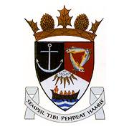
THE ROYAL BURGH OF KILRENNY, ANSTRUTHER & CELLARDYKE COMMUNITY COUNCIL MEETING Monday 8th August 2022, 7:30pm The East Neuk Centre

1. Welcome & Apologies
2. Approval of Minutes & Matters Arising / Declaration of interests
3. Questions from the public
4. Input from Carl Van Der Lee re Multi Use Path (Dreelside)
5. Multi Use Path
6. Planning/Licensing Matters
7. Anstruther Mobile Post Office
8. RNLI – Transport Update
9. Secretary’s Report
10. Treasurer’s Report
11. Councillor’s Report
12. Representation from other groups
a) Floral Group
b) Murray Library Trustees
13. AOCB

