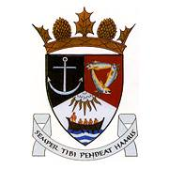
THE ROYAL BURGH OF KILRENNY, ANSTRUTHER & CELLARDYKE COMMUNITY COUNCIL MEETING 20th JULY 2020, 7.30PM ONLINE
VIA ZOOM ID: 443 839 9826
PASSWORD: Anstruther

1. Welcome & Apologies
2. Approval of Minutes & Matters Arising
3. Questions/Emails from the public
4. Secretaries Report
5. Treasurer’s Report
6. Councillor’s Report
7. COVID-19 / Community ENCEPT Response
8. East Neuk & Landward Community Policing
9. Planning Issues (inc. Ladywalk)
10 .Representation from other groups
a) Floral Group
b) Murray Library Trustees
c) SLC
d) Multi Use Path
11. AOCB

