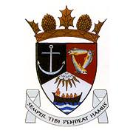
THE ROYAL BURGH OF KILRENNY, ANSTRUTHER & CELLARDYKE COMMUNITY COUNCIL MEETING 14th DECEMBER 2020, 7.30PM ONLINE
VIA ZOOM ID: 825 4163 4891
PASSWORD: Anstruther

1. Welcome & Apologies
2. Approval of Minutes & Matters Arising
3. Questions/Emails from the public
4. Christmas Plans
5. RNLI / PAS update
6. Common Good Fund Update
7. East Neuk App
8. Rewilding
9. Muir Homes Development
10. Secretaries Report
11. Treasurer’s Report
12. Councillor’s Report
13. Representation from other groups
a) Floral Group
b) Murray Library Trustees
c) SLC
d) Multi Use Path
14. AOCB

