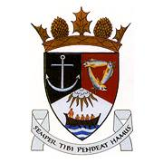
THE ROYAL BURGH OF KILRENNY, ANSTRUTHER & CELLARDYKE COMMUNITY COUNCIL MEETING 27th JULY 2020, 7.30PM ONLINE
VIA ZOOM ID: 835 6417 0052
PASSWORD: Anstruther

1. Welcome & Apologies
2. Approval of Minutes & Matters Arising
3. Questions/Emails from the public
4. Input from Planning Aid Scotland – RNLI Planning Application
5. Secretaries Report
6. Treasurer’s Report
7. Councillor’s Report
8. COVID-19 / Community ENCEPT Response
9. East Neuk & Landward Community Policing
10 Planning Issues (inc. Ladywalk)
11 Representation from other groups
a) Floral Group
b) Murray Library Trustees
c) SLC
d) Multi Use Path
12. AOCB

