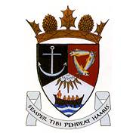
THE ROYAL BURGH OF KILRENNY, ANSTRUTHER & CELLARDYKE COMMUNITY COUNCIL
13th January 2020 7.30pm at the east neuk centre
AGENDA

- Welcome & Apologies

- Declaration of Interest

- Approval of minutes and matters arising

- Questions from the public

- Environmental Matters

- Secretary’s Report

- Treasurer’s Report

- Councillor’s Report

- BT Consultation

- Planning Legislation Changes

- Community Council Scheme Review - Boundaries

- Place Standard – Community Consultation

- Coast & Water Community Fund

- Feedback from other groups
- Floral
- SLC
- ENCC Forum
- Harbour
- Social Media
- Multi Use Path
- Murray Library Trust

- AOCB

